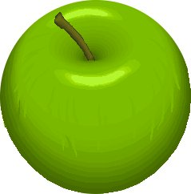  1 | 2 | 3 | 4
1 | 2 | 3 | 4
1 | 2 | 3 | 4
1 | 2 | 3 | 4
1 | 2 | 3 | 4
1 | 2 | 3 | 4
1 | 2 | 3 | 4
1 | 2 | 3 | 4
1 | 2 | 3 | 4
1 | 2 | 3 | 4
1 | 2 | 3 | 4
1 | 2 | 3 | 4

